# DevOps Project – Java Base Application Deploying in Tomcat Serverr CI/CD

Using OS :- Kali linux

Creating Two VM :- (VM-1= Jenkins- Server),(VM-2=Tomcat-Server) 

User

Build Code

Code pulls

Deploying

**VM-1** CMD

Step-1

hostname Jekins-Server

Vim /etc/hostsame

Vim /etc/hosts

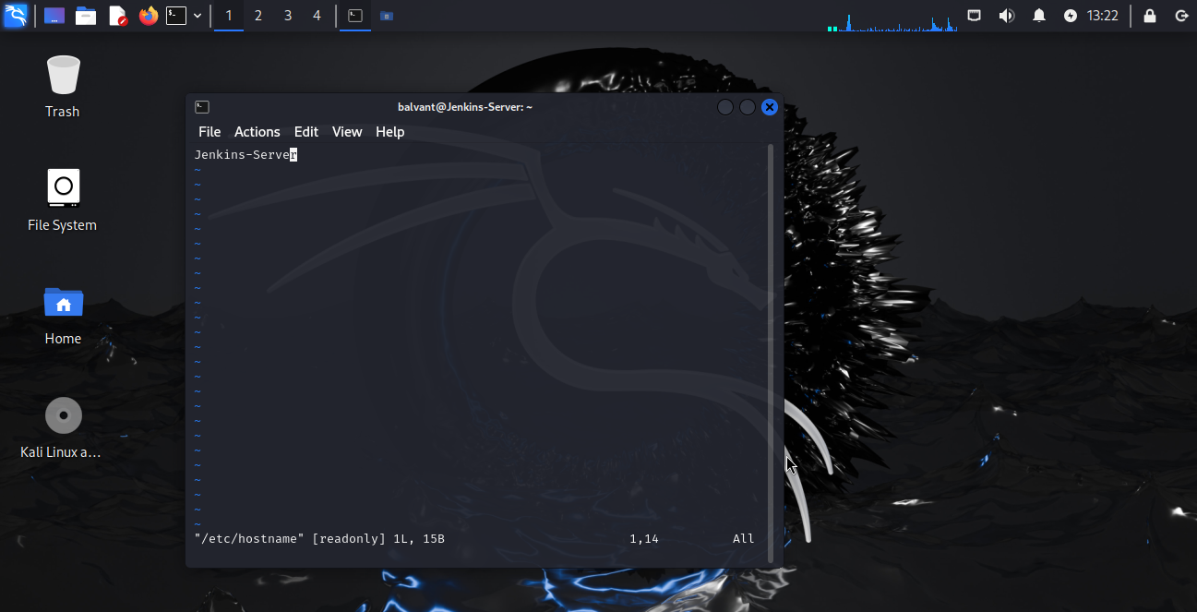

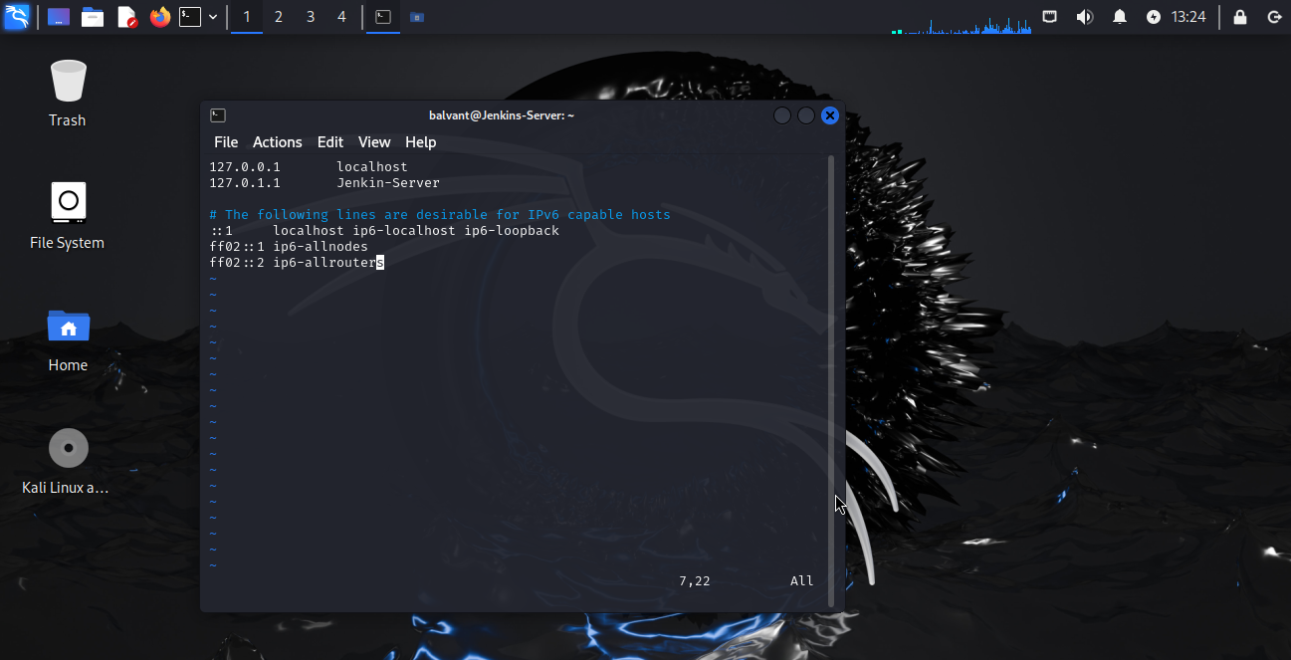

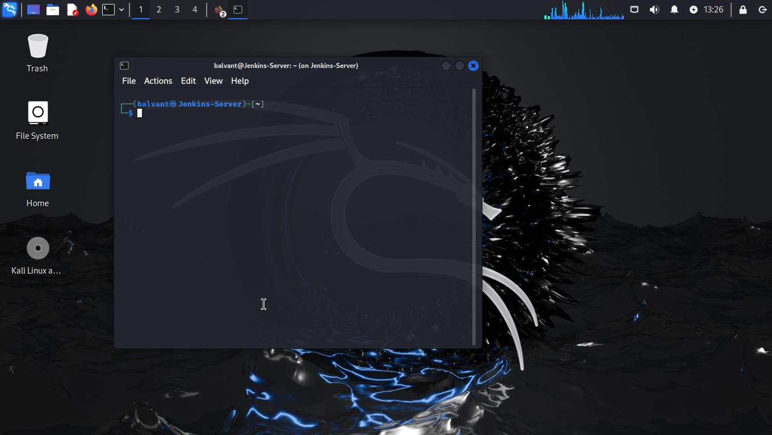

Step-2

**Installing Java**

Sudo apt update && sudo apt Install openjdk-11-jdk

Java -version

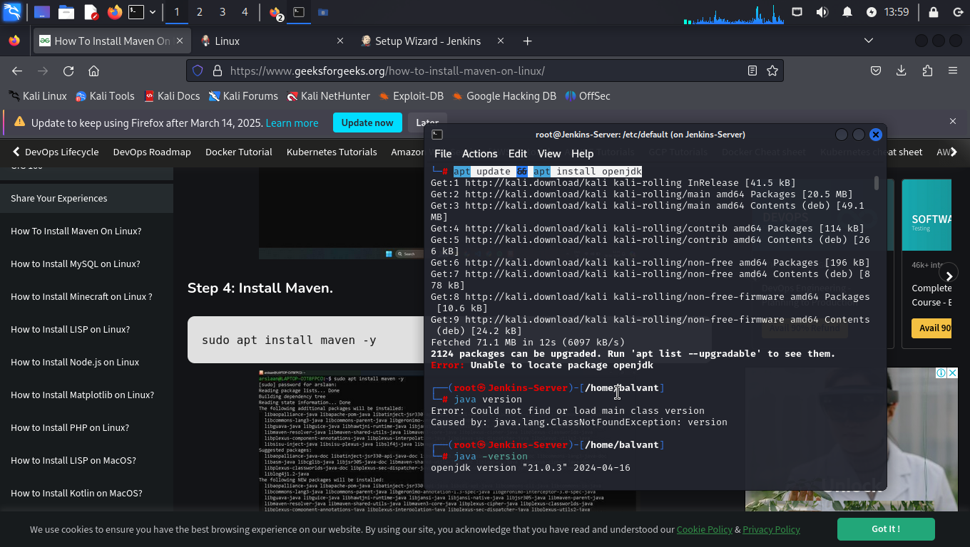

**Installing Jenkins**

sudo wget -O /usr/share/keyrings/jenkins-keyring.asc

https://pkg.jenkins.io/debian/jenkins.io-2023.key

echo "deb [signed-by=/usr/share/keyrings/jenkins-keyring.asc]" \

/etc/apt/sources.list.d/jenkins.list **>** /dev/null

sudo apt-get update

sudo apt-get install Jenkins

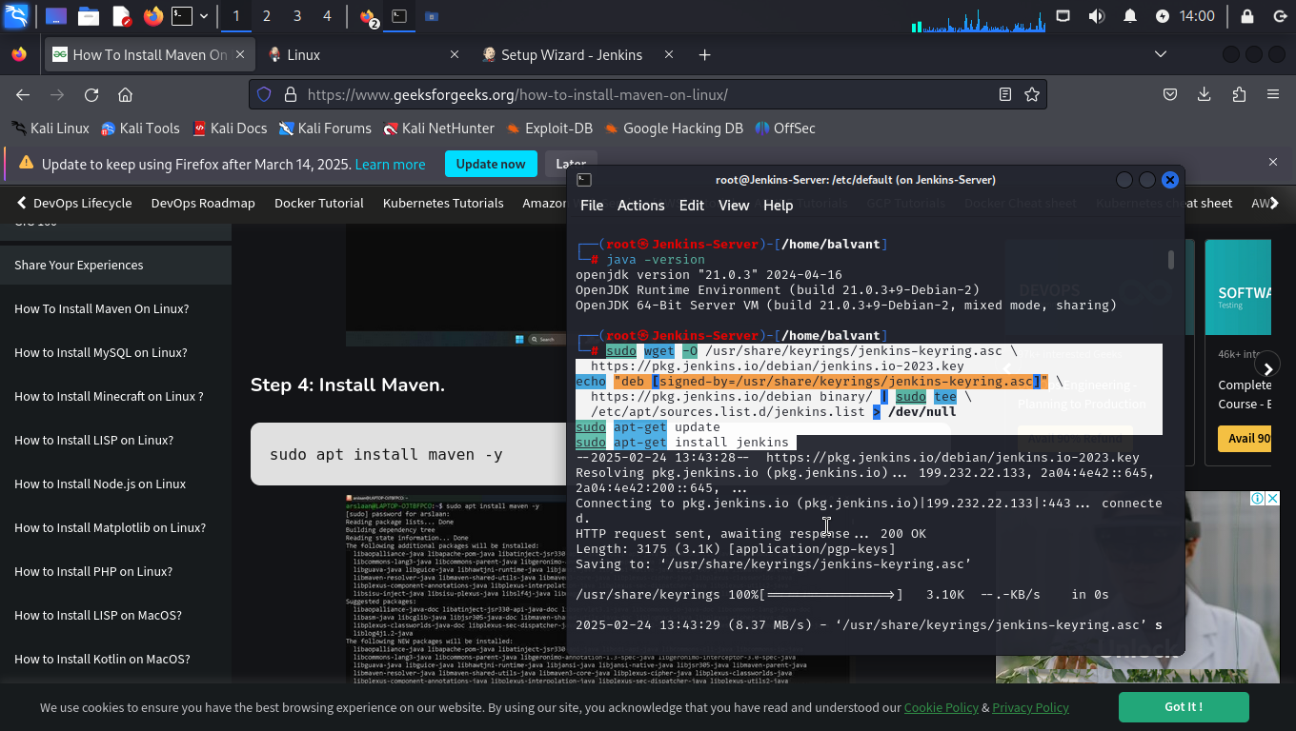

**Installing Maven**

Sudo apt update && sudo apt install maven

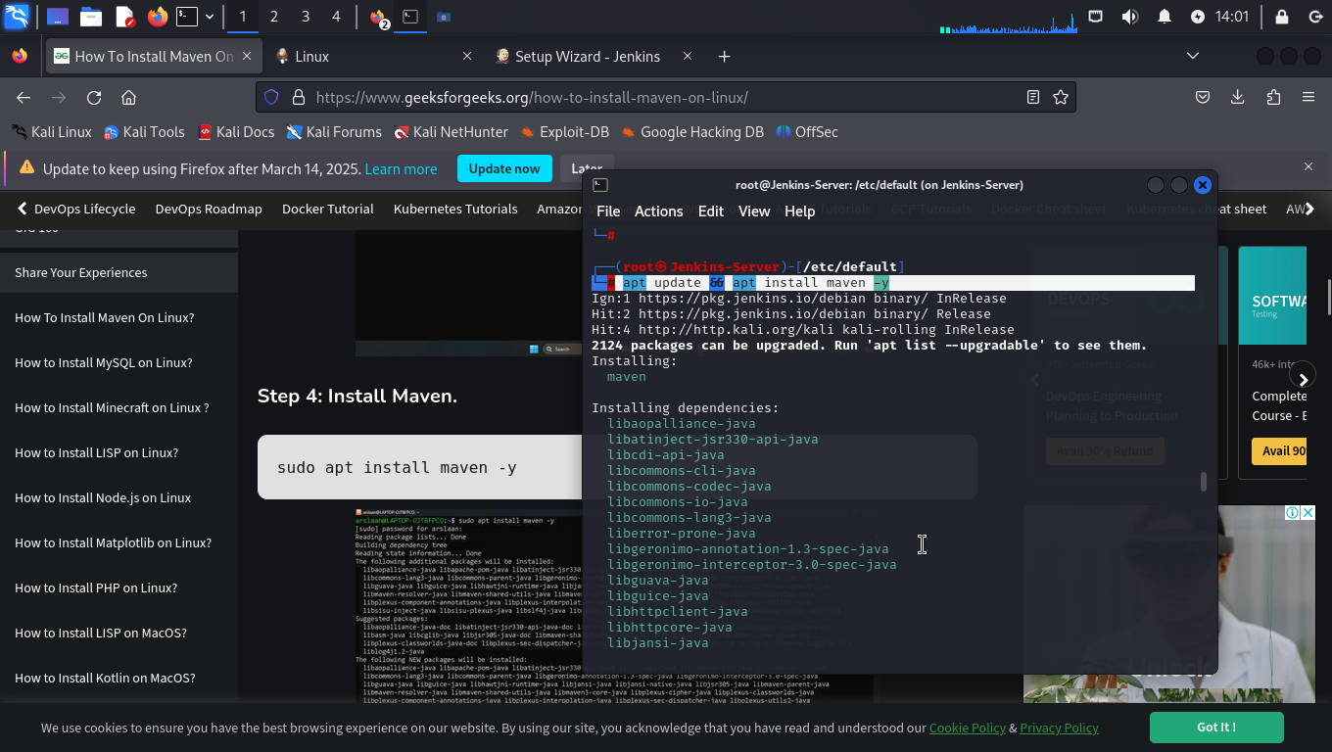

Step -3

Ip addr (copy ip & browse ip:8080)

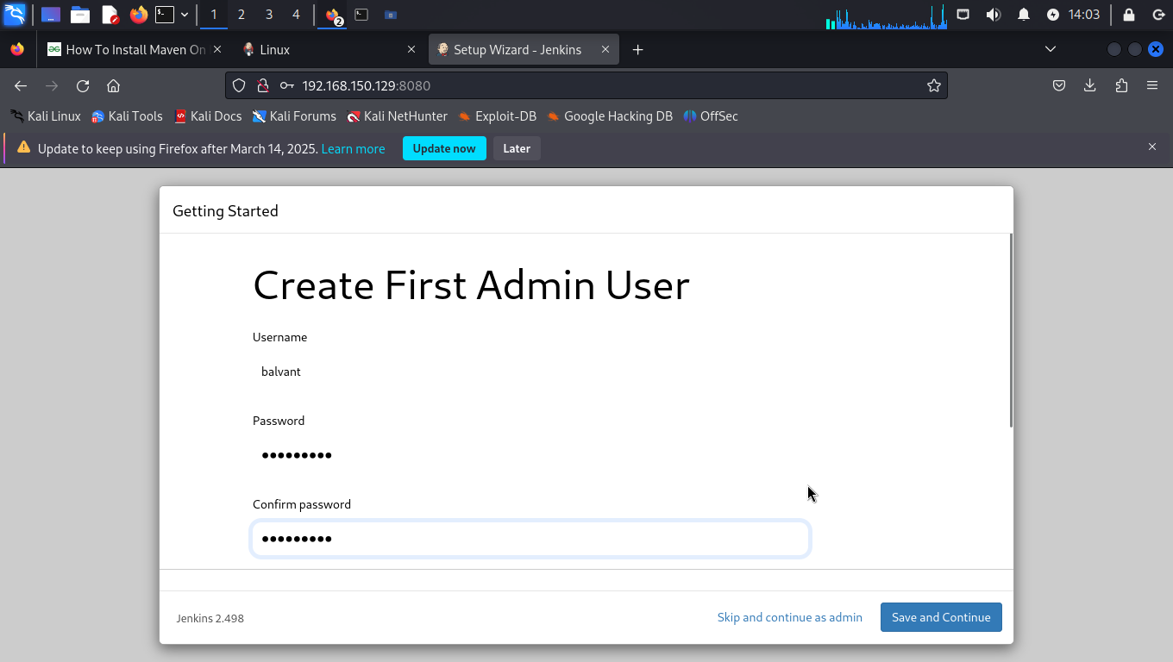

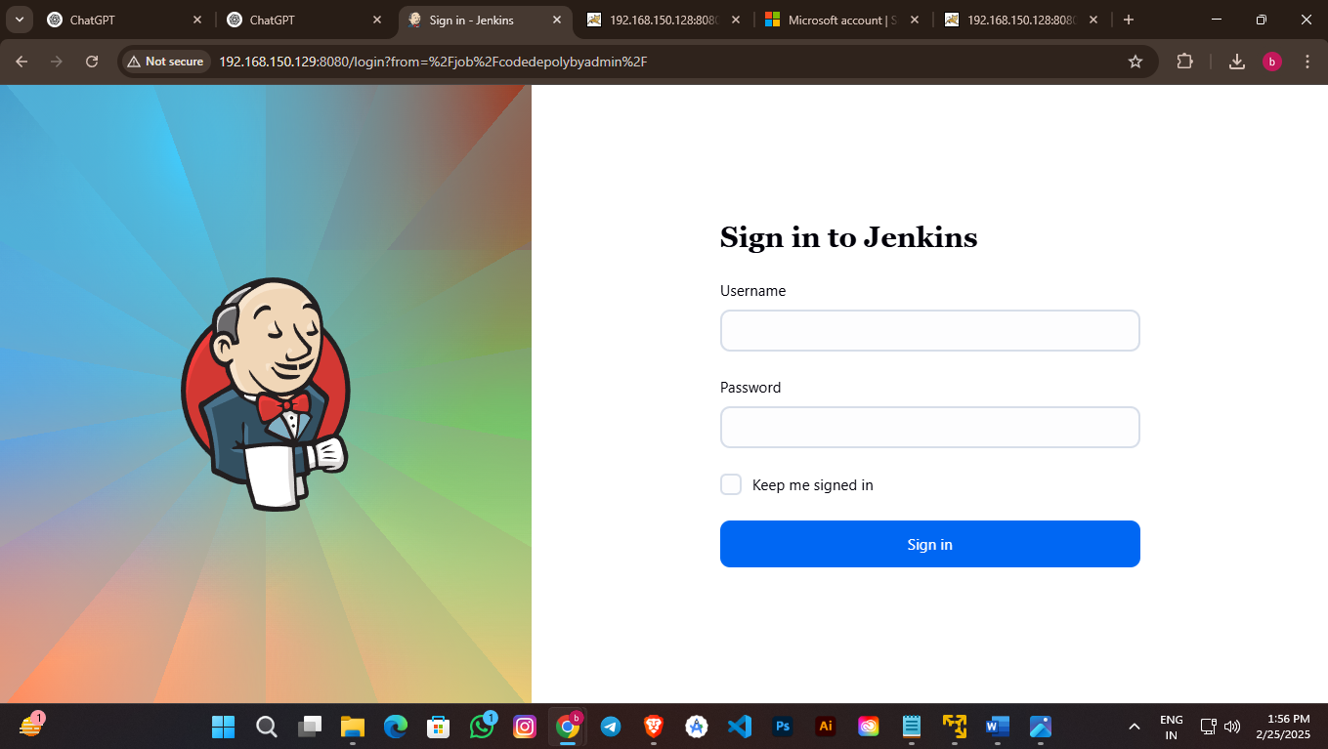

Jeknkins Plugins:- Manage Jenkins – plugins – Available Plugins – Maven Integration (install)

Jeknkins Plugins:- Manage Jenkins – plugins – Installed plugin - GIthub brance source(untick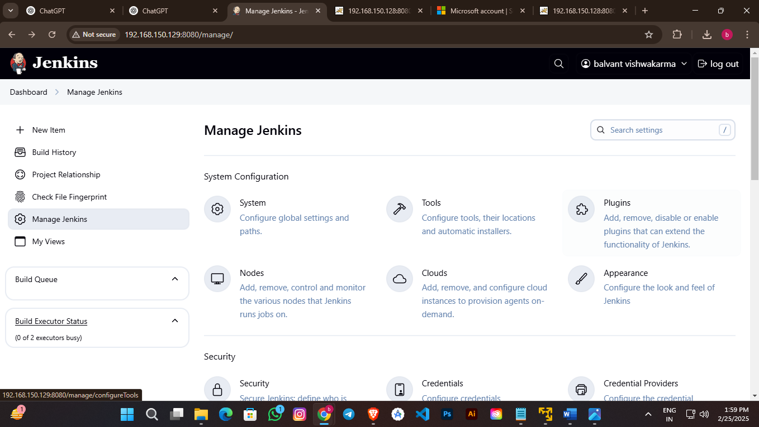)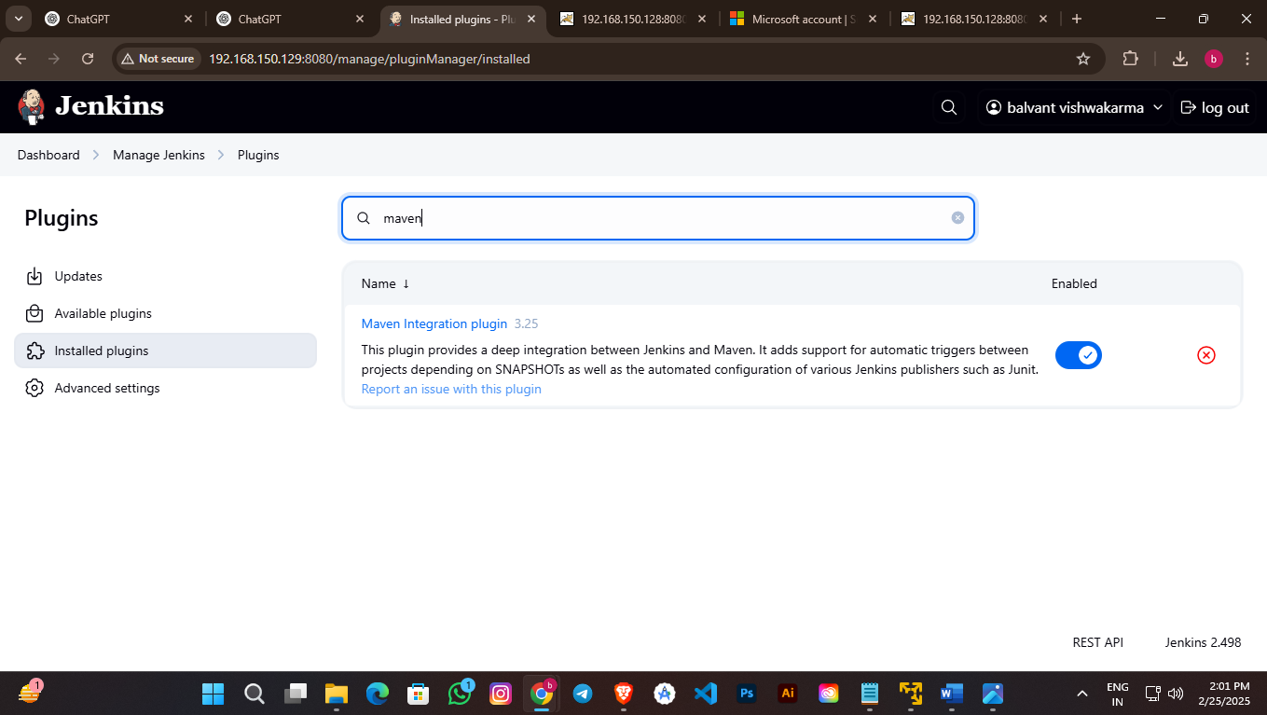

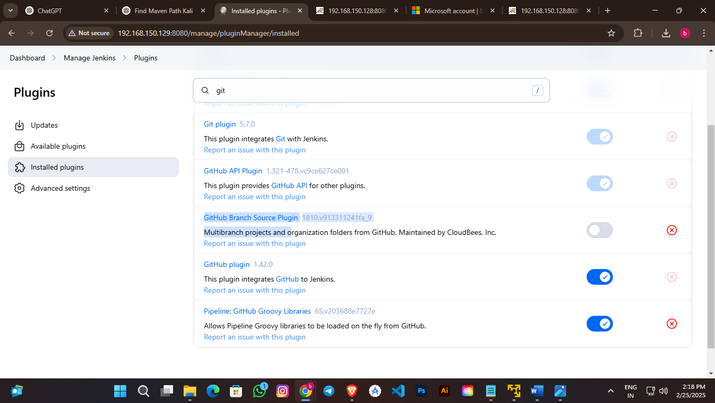

Jeknkins Plugins:- Manage Jenkins - Tools – add JDK -add MAVEN – apply -save

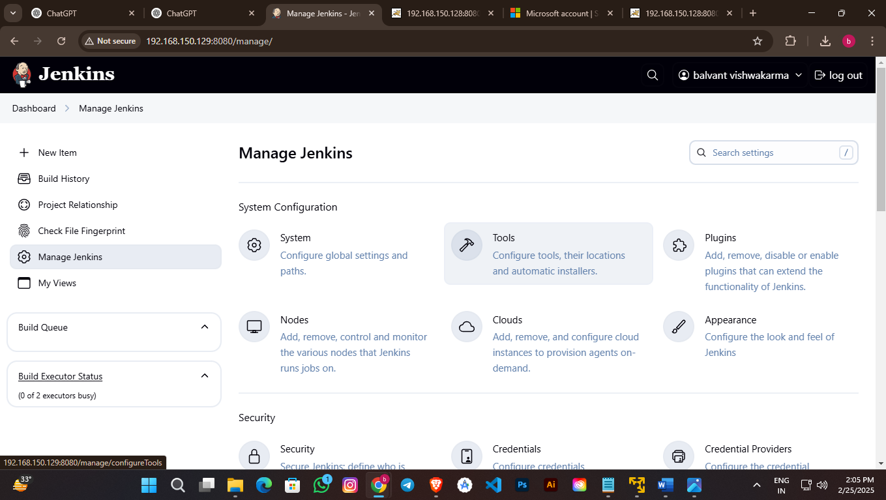

Java Path

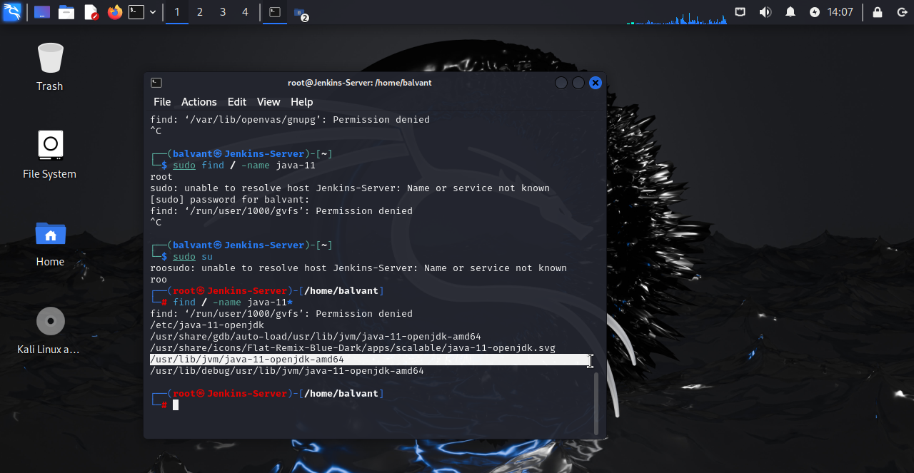

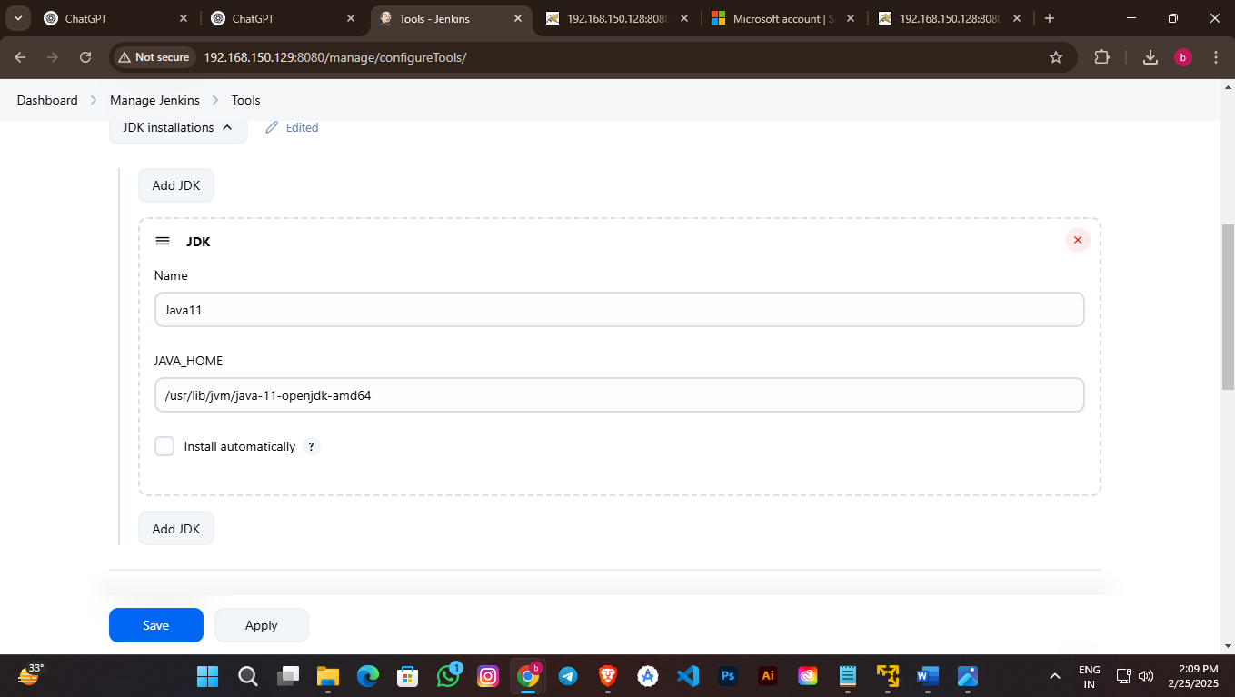

Maven Path

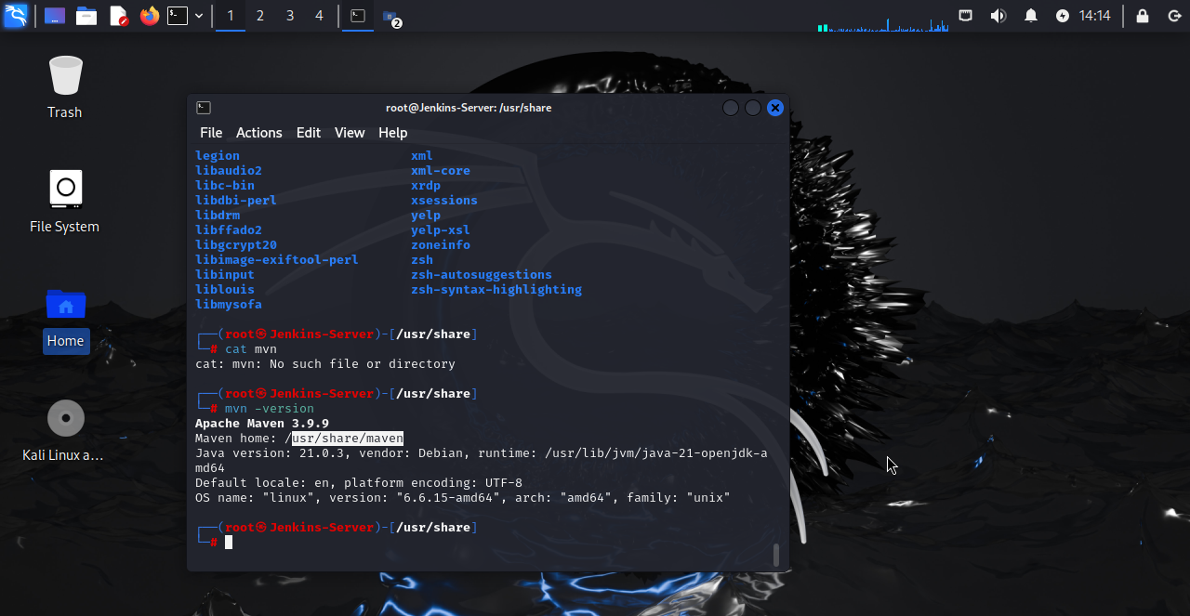

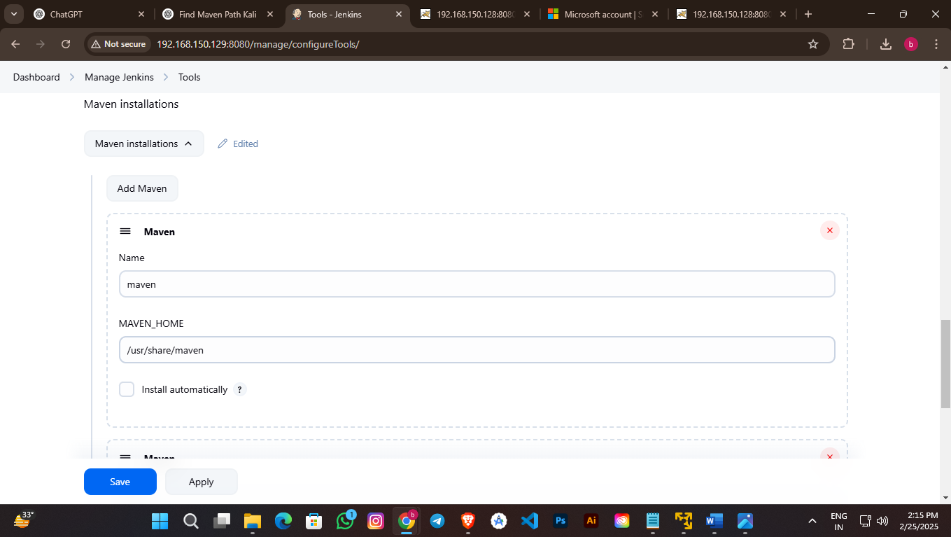

**Installing Git**

Sudo apt update && apt install git

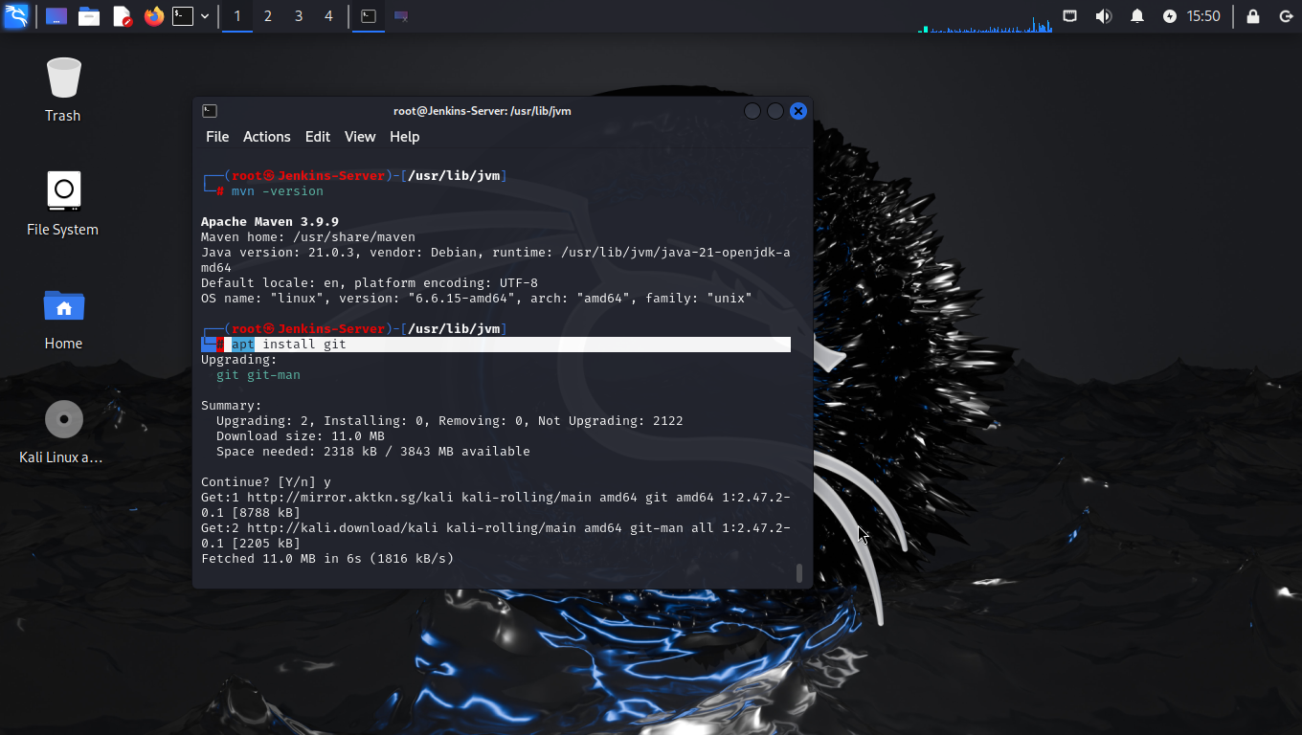

Jenkins :- New Item – select github – add git hub repository (Branch – Main) – build - pom.xml – Gols and Options(clean install) – apply -save

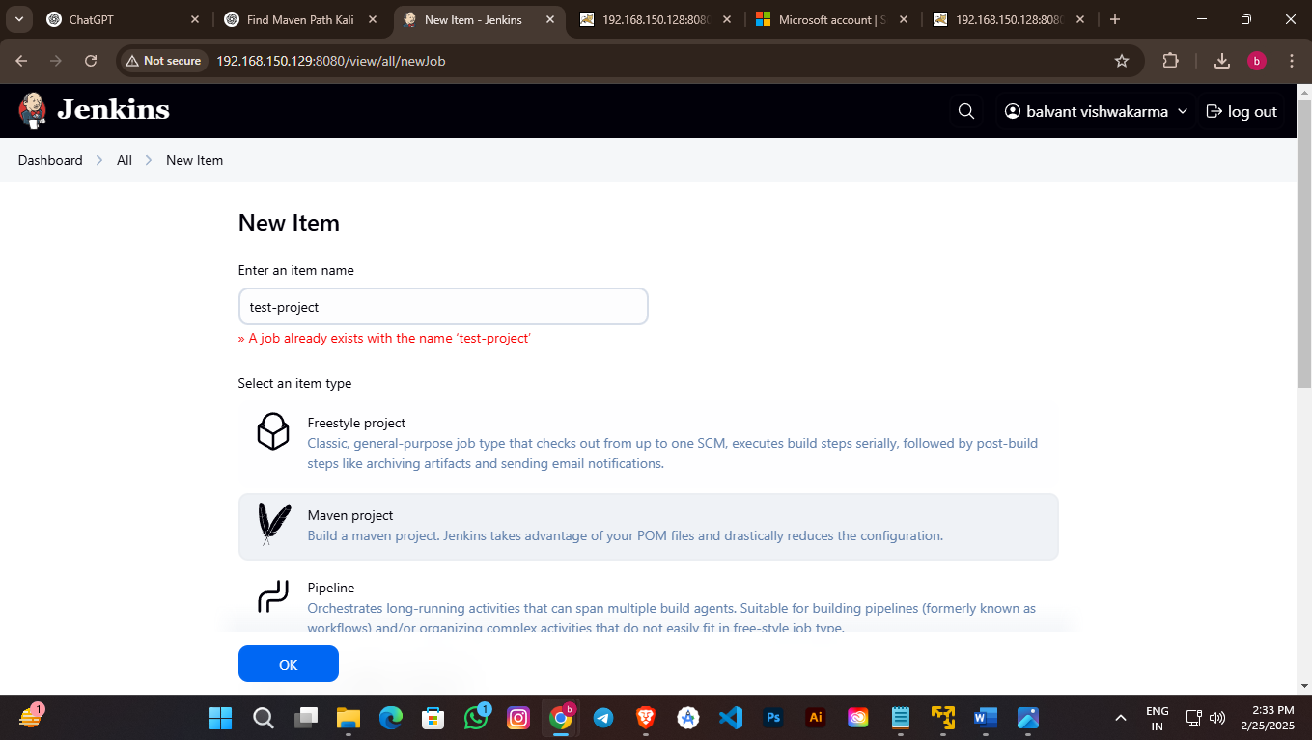

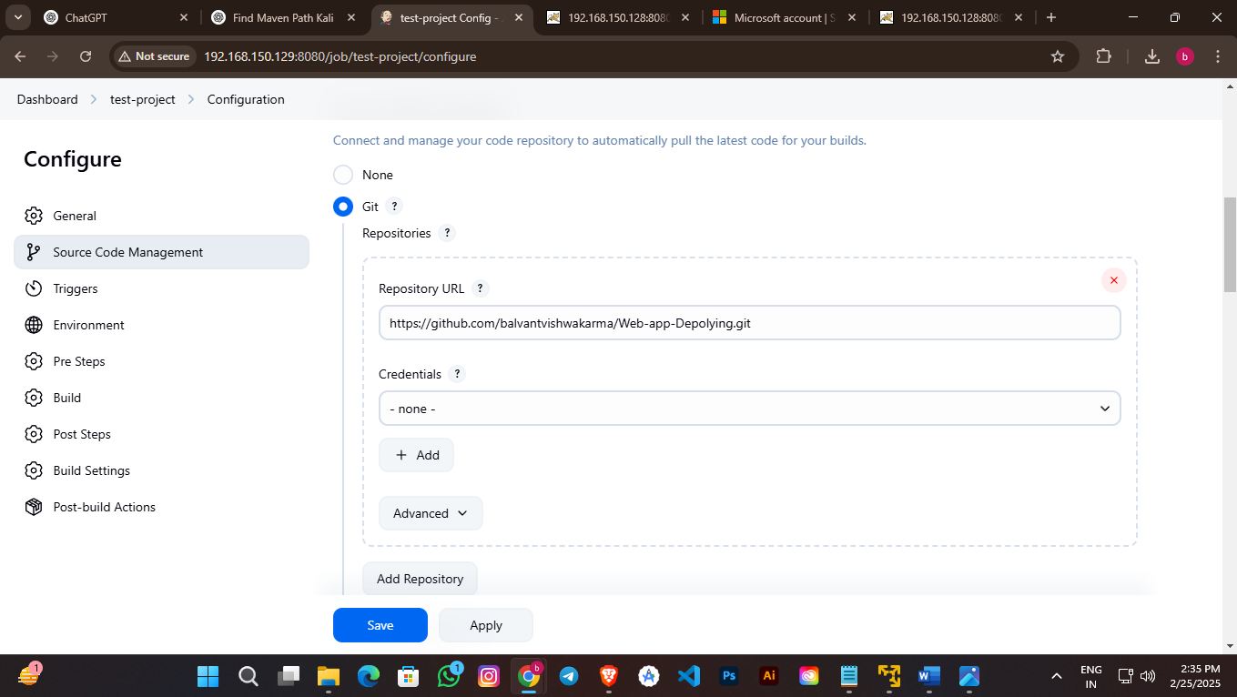

Bulid

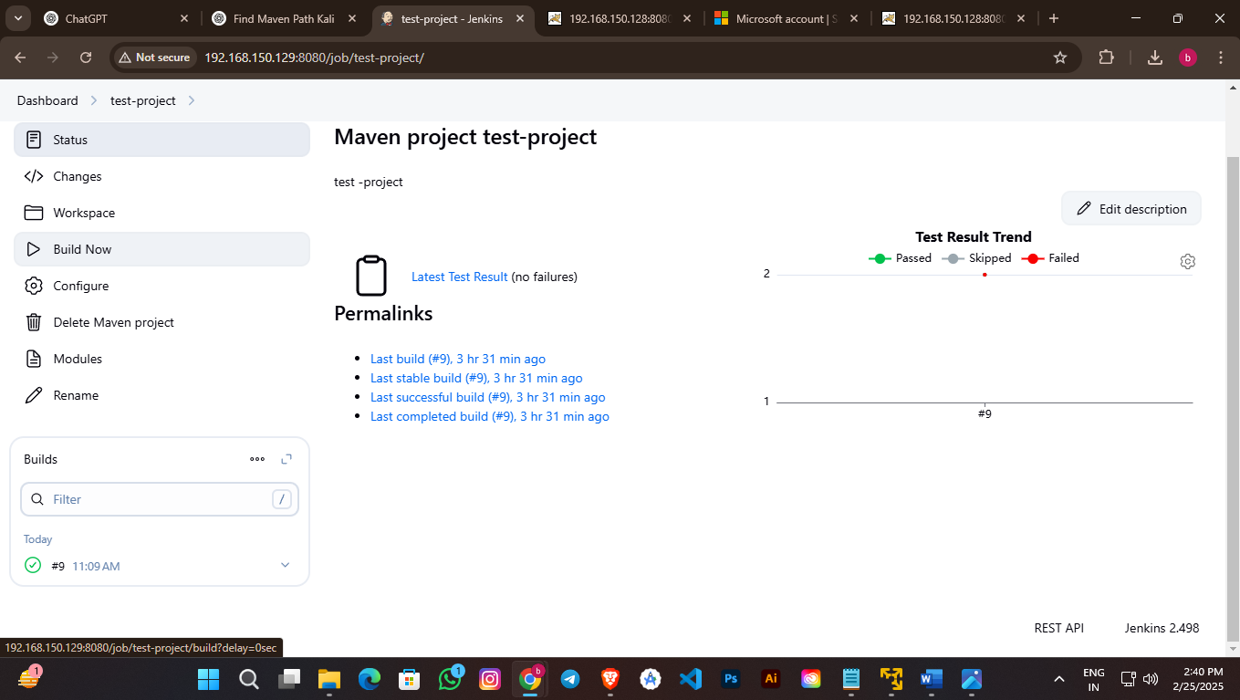

Step-4

VM-2 :- **Java &** **Installing Tomcat**

Sudo apt update && apt install openjdk-11jdk

Cd /opt

wget <https://archive.apache.org/dist/tomcat/tomcat-9/v9.0.21/bin/apache-tomcat-9.0.21.tar.gz>

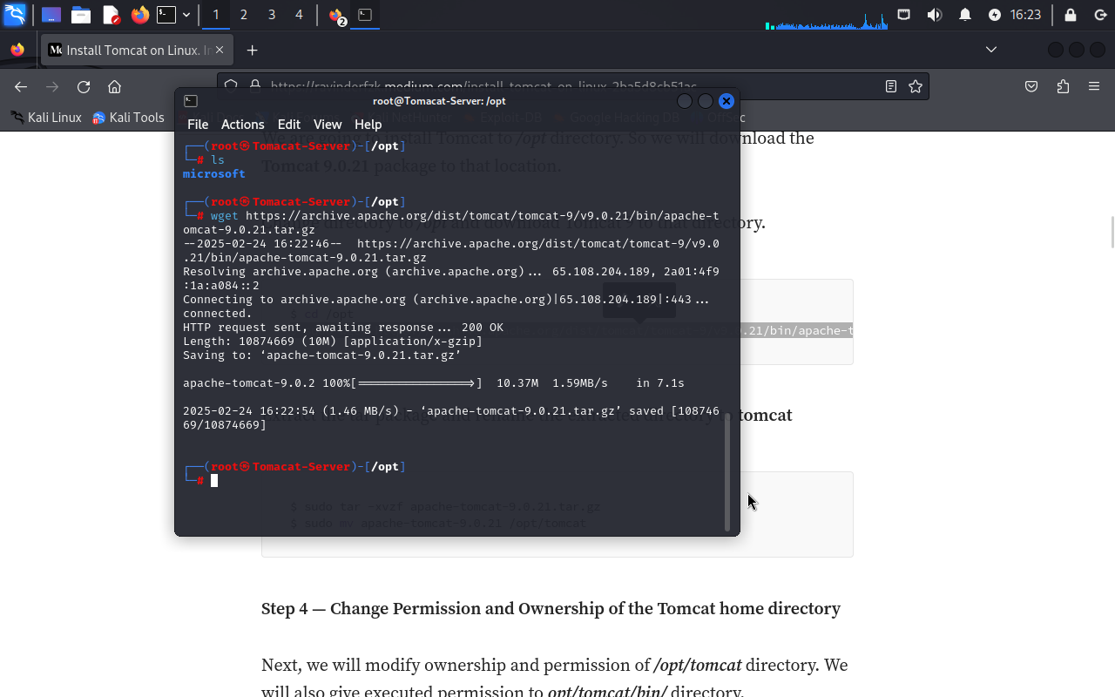

Sudo tar -xvzf apache-tomcat-9.0.21.tar.gz

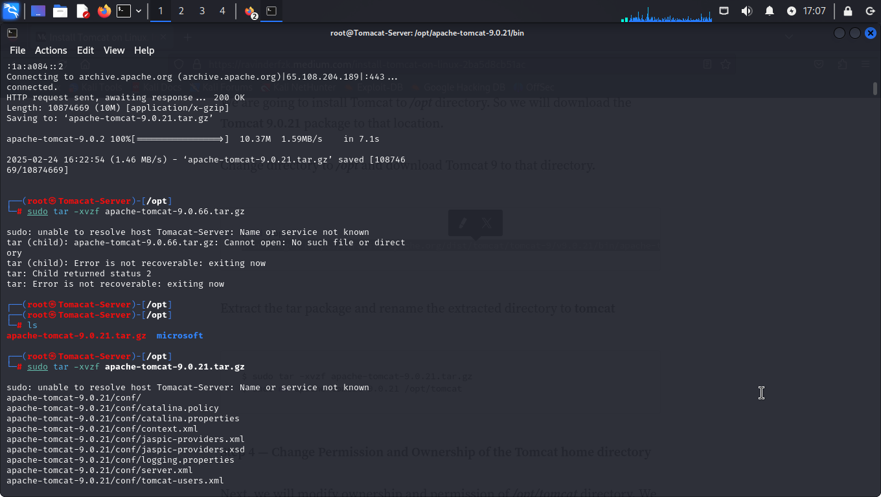

cd /opt/apache-tomcat-9.0.21/bin

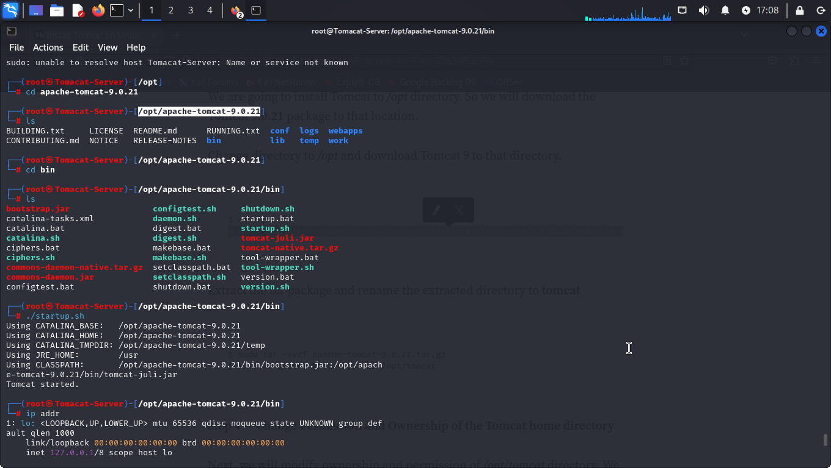

vim /opt/apache-tomcat-9.0.21/webapps/host-manager/META-INF/context.xml

vim /opt/apache-tomcat-9.0.21/webapps/manager/META-INF/context.xml

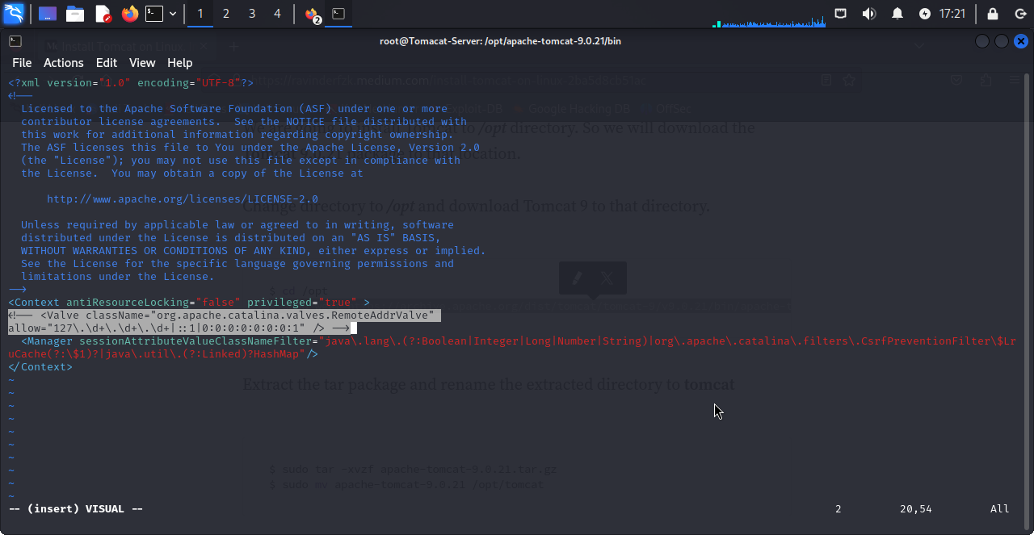

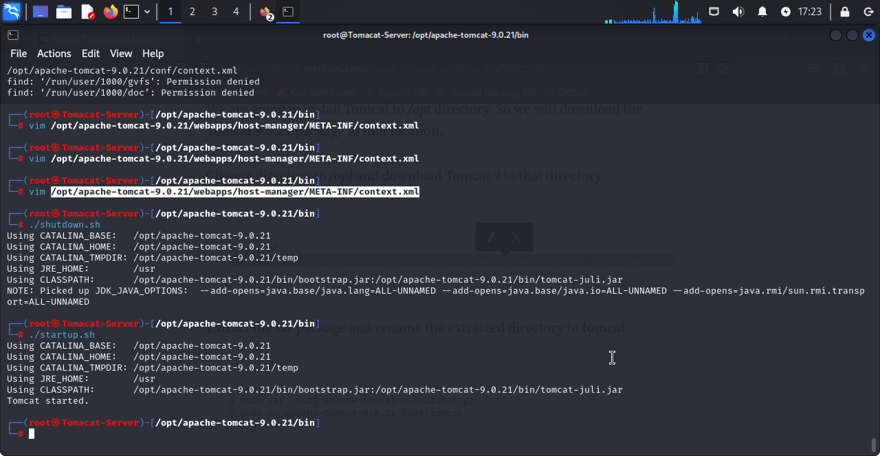

vim /opt/apache-tomcat-9.0.21/conf/tomcat-users.xml

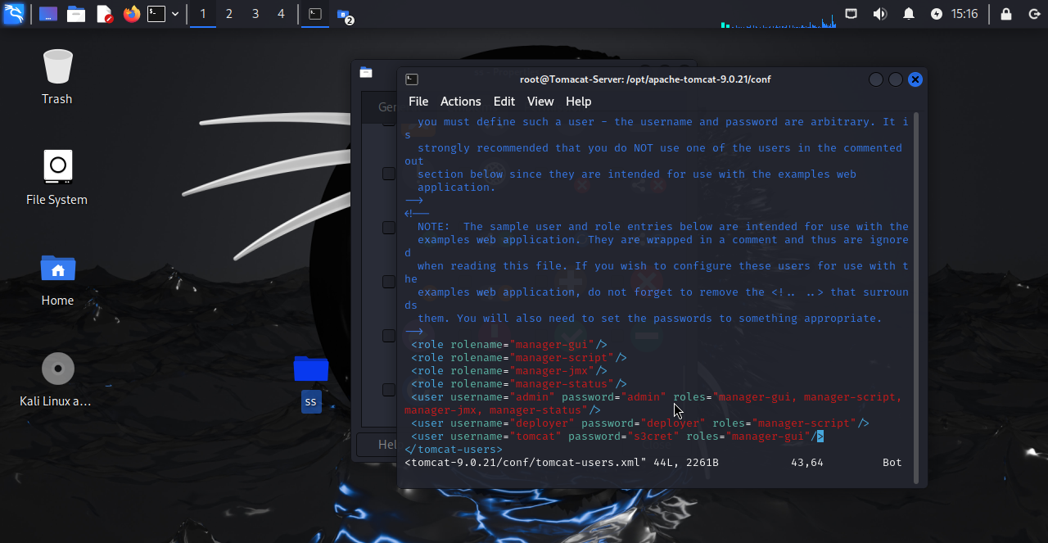

Ip addr (copy ip and Browse – ip:8080)

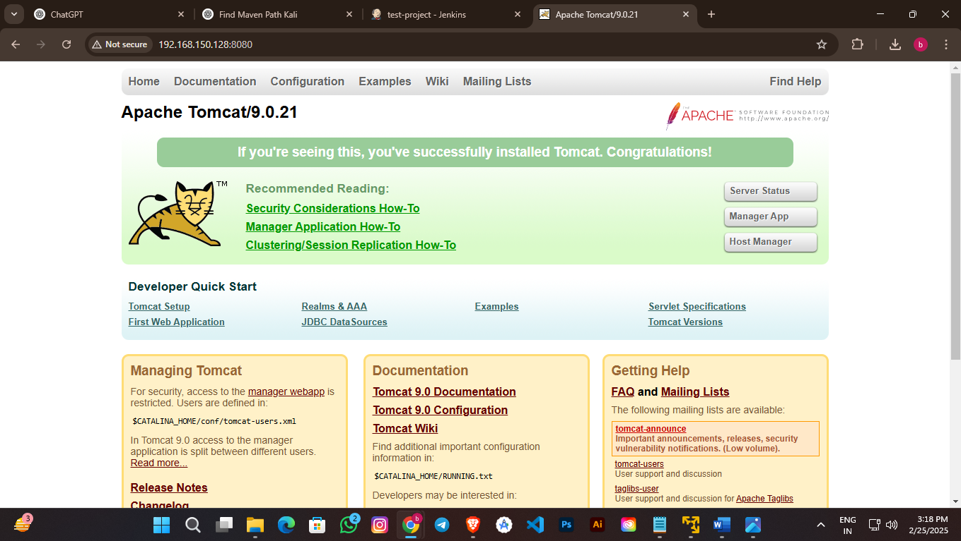

**Integration Tomcat server with Jenkins**

Jeknkins Plugins:- Manage Jenkins – plugins – Available Plugins - Deploy to container (install)

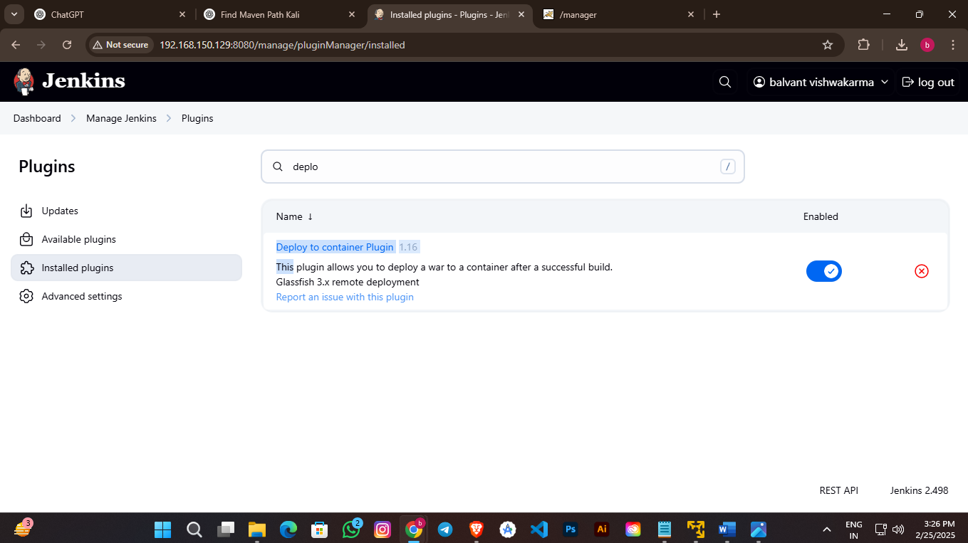

Jenkins - [Manage Jenkins](http://192.168.150.129:8080/manage/) - [Credentials](http://192.168.150.129:8080/manage/credentials/) - [System](http://192.168.150.129:8080/manage/credentials/store/system/) - [Global credentials (unrestricted)](http://192.168.150.129:8080/manage/credentials/store/system/domain/_/)- add [Credentials](http://192.168.150.129:8080/manage/credentials/)

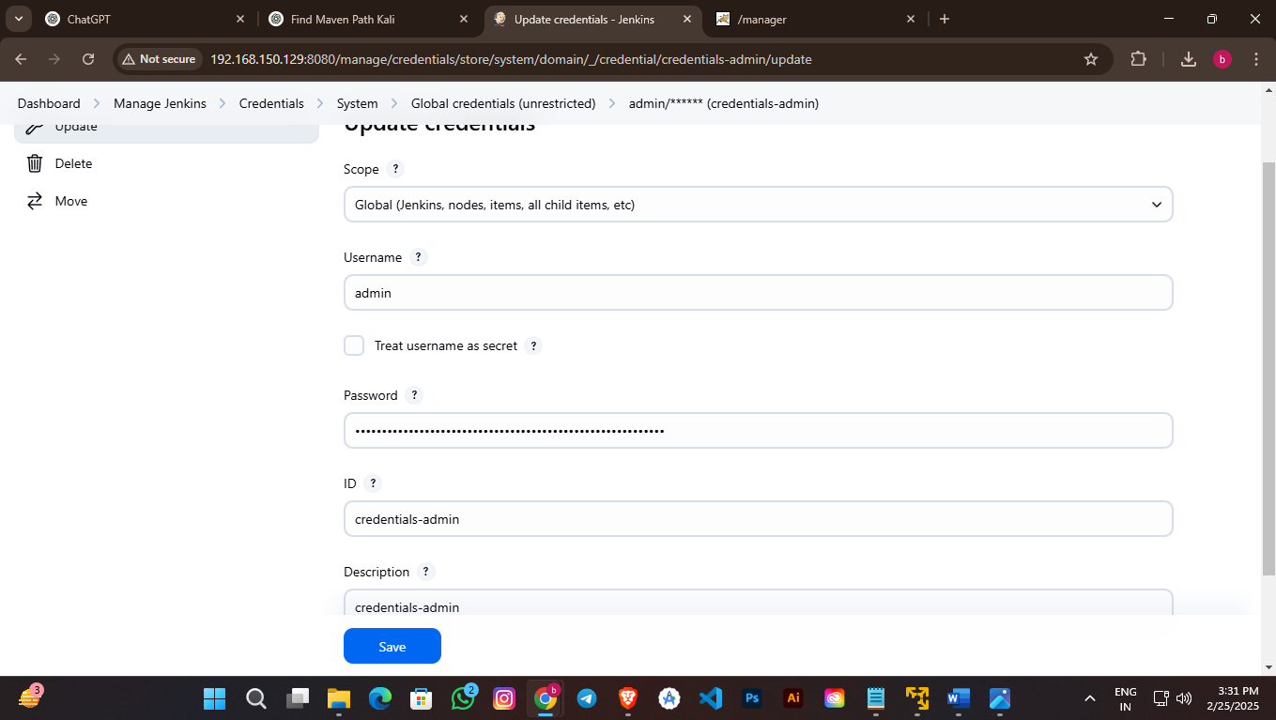

Jenkins – New Item -maven- ok

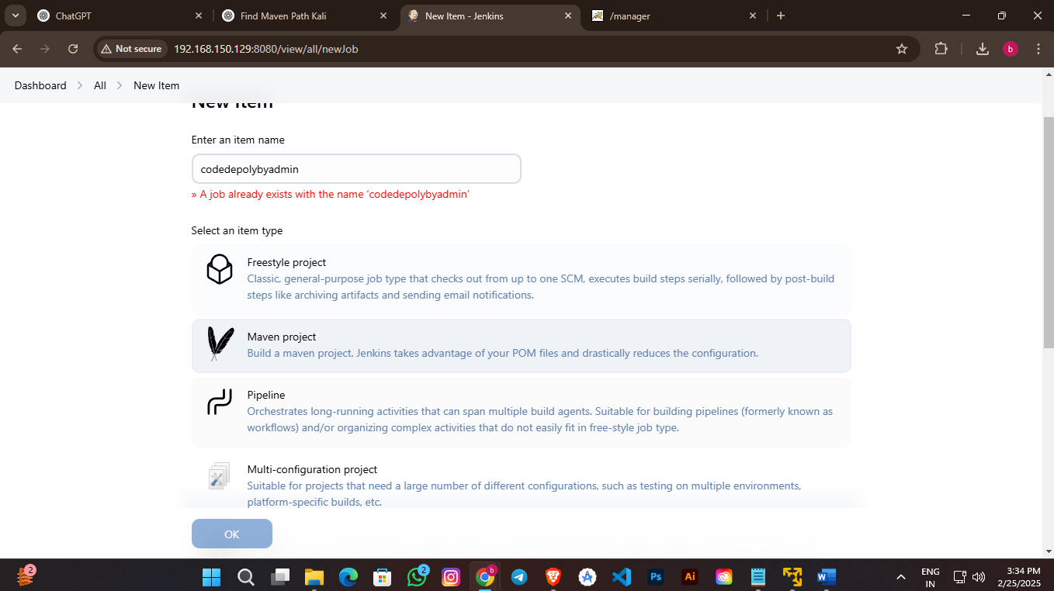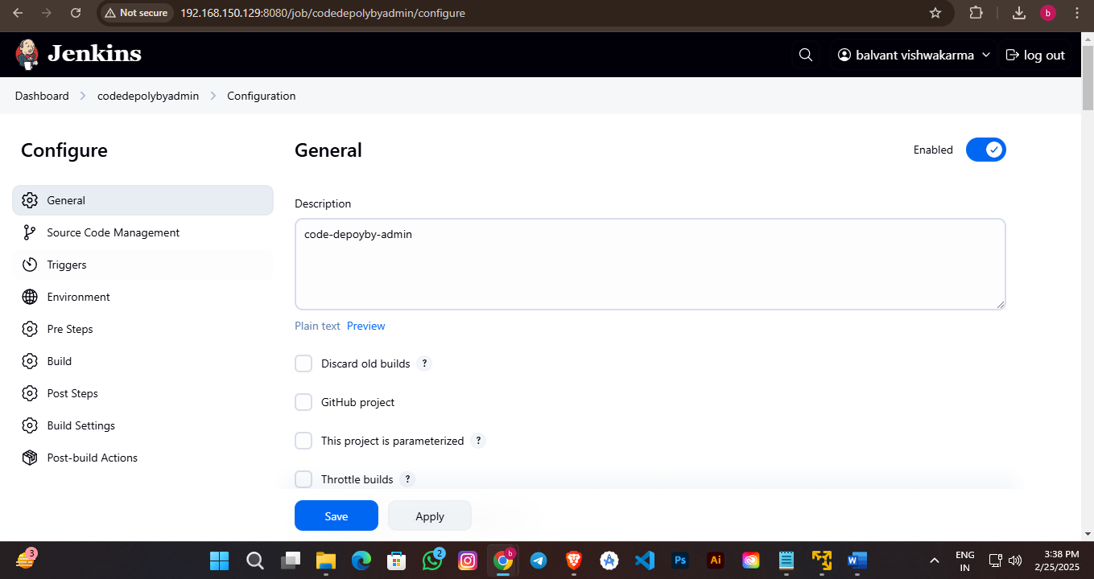

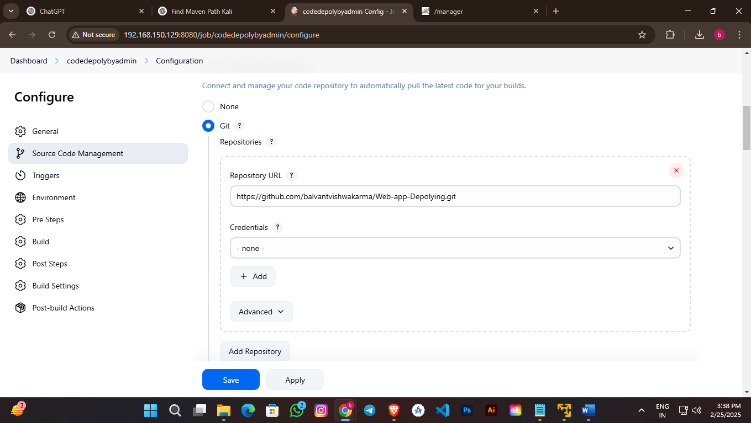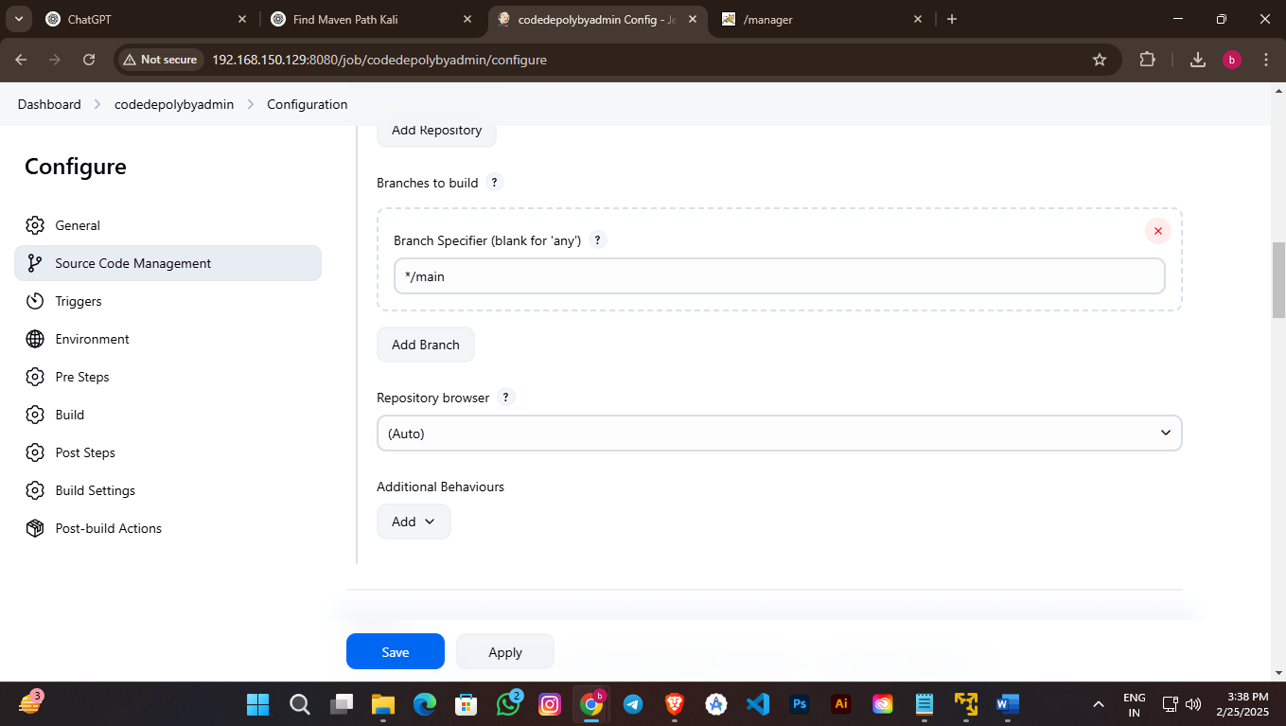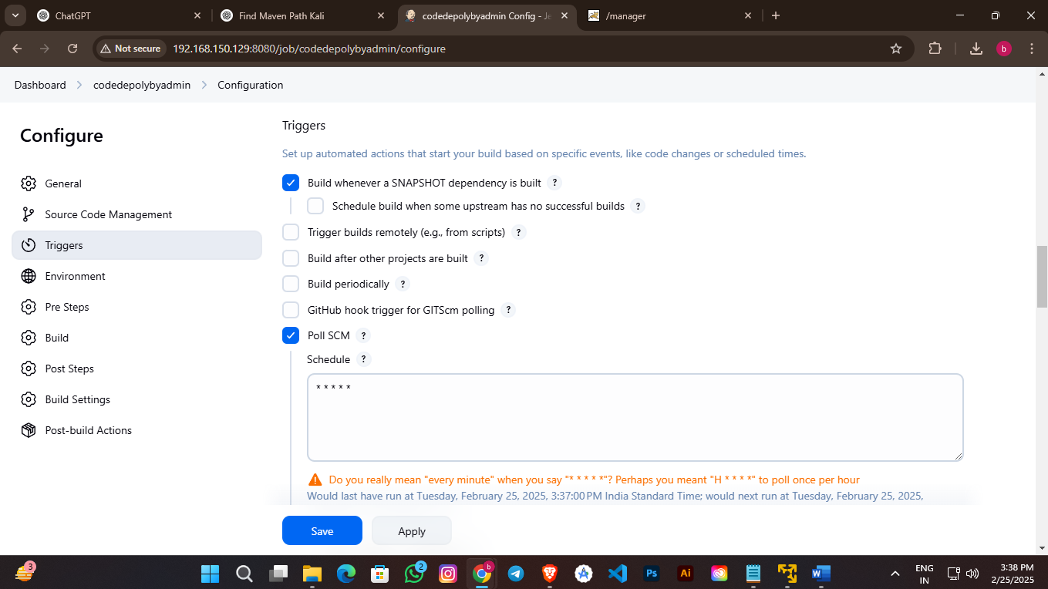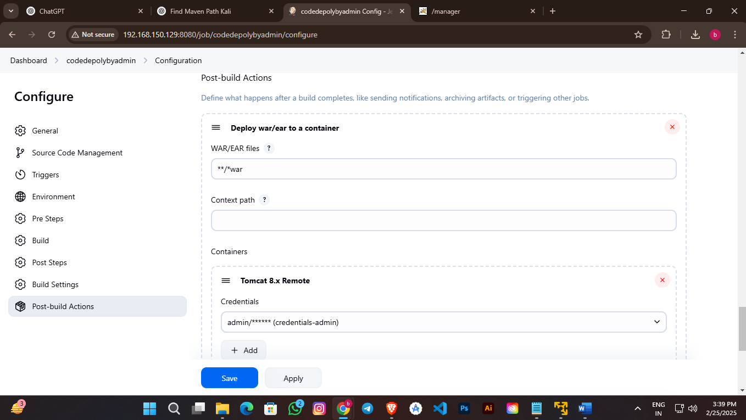

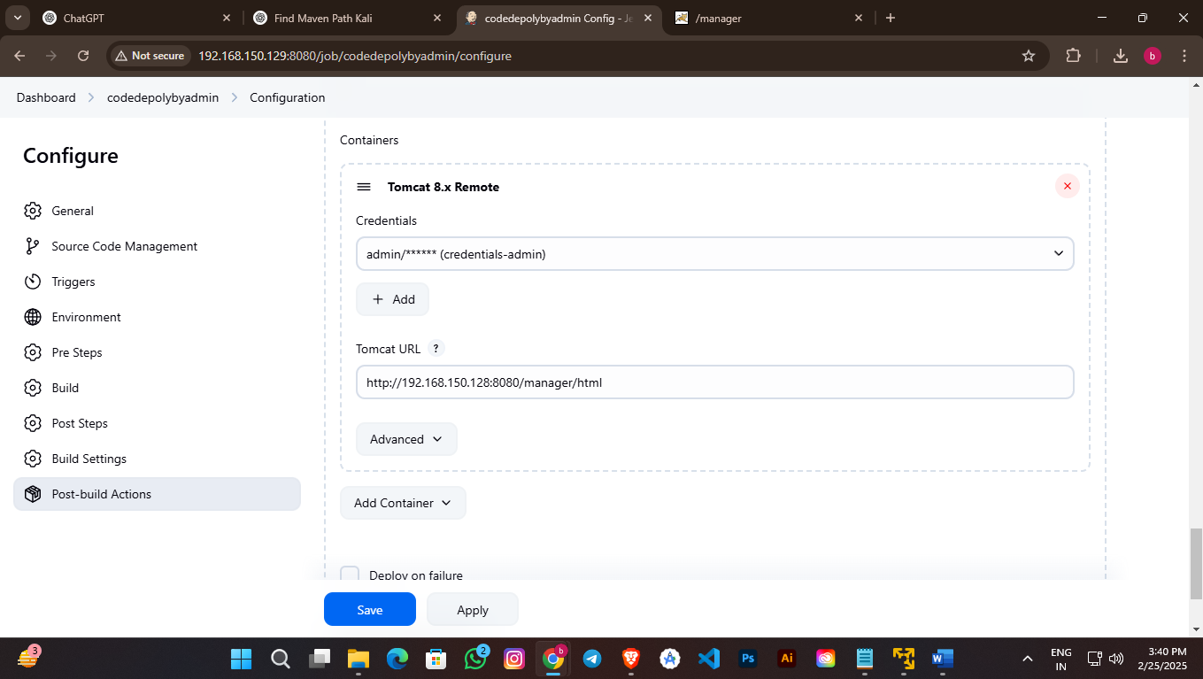

Jenkins :- select Project and Run (Bulid)

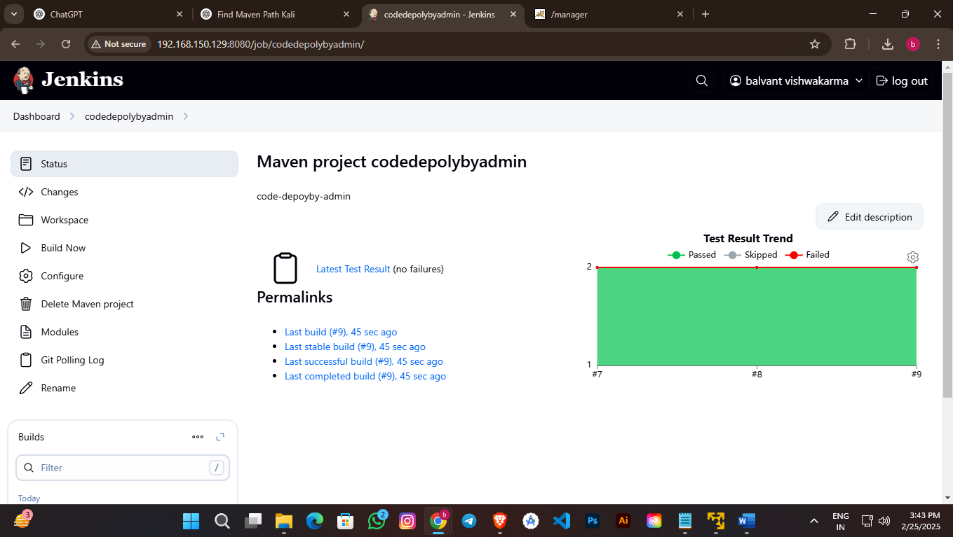

Now Verify in Tomcat Server

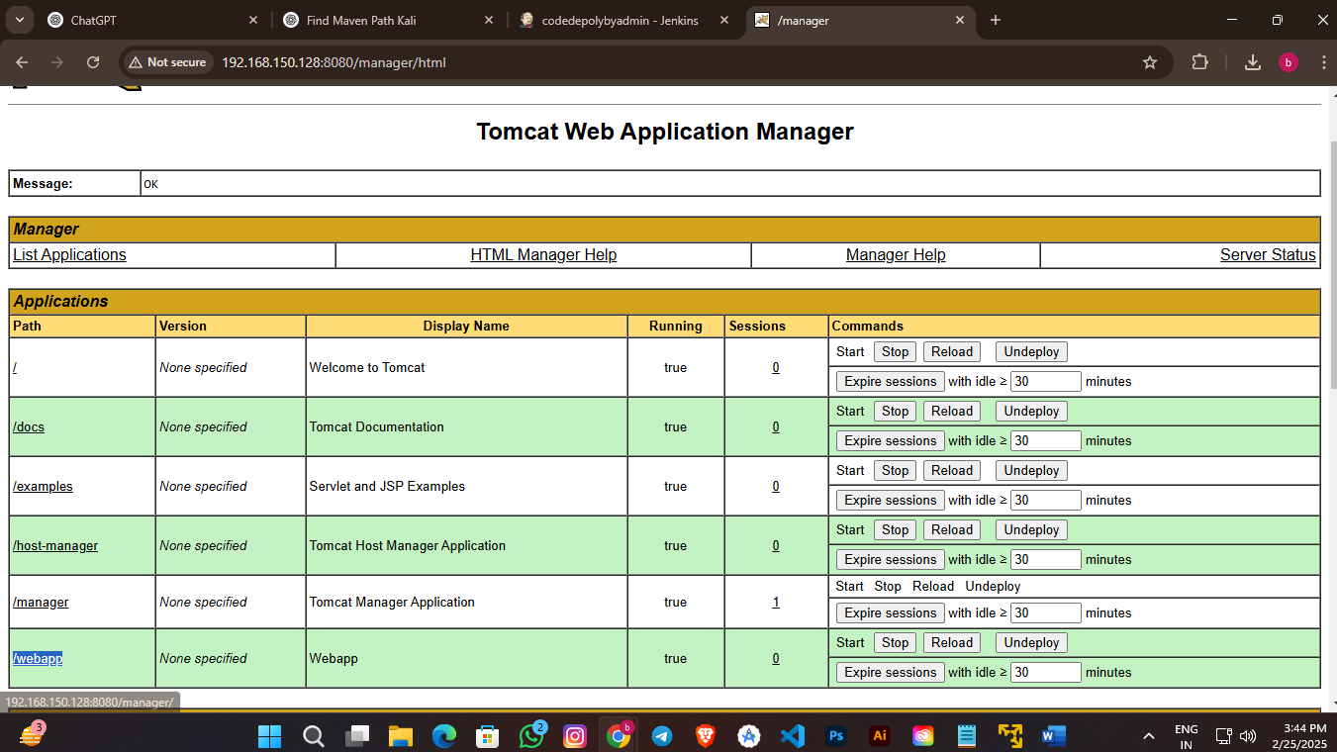

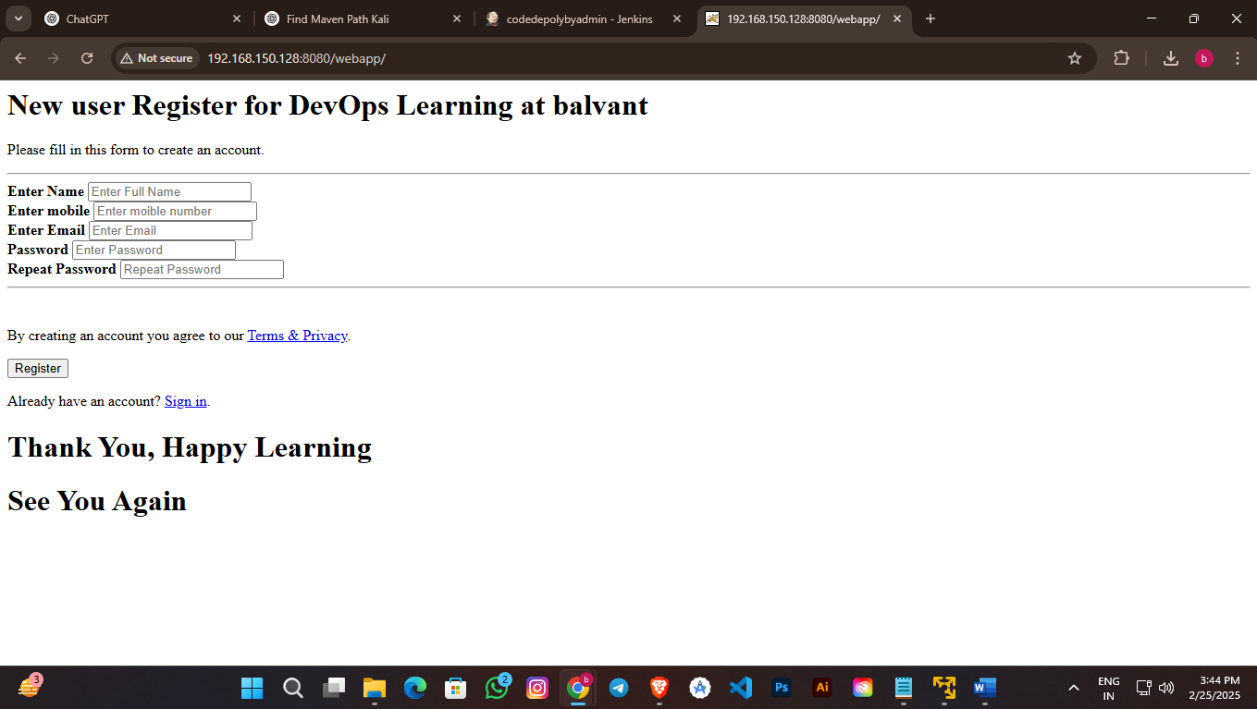

Now Change Code and check its working or not

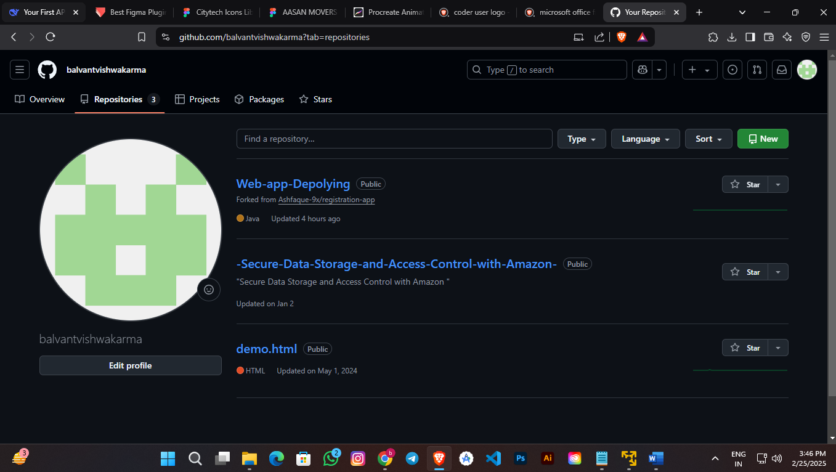

Complete Response

